***Semaine du 25/03 au 29/03***



**Œufs durs en salade**

**🞟🞟🞟**

**Rôti de veau**

**Purée patate douce**

**🞟🞟🞟**

**Petit suisse aromatisé**

**🞟🞟🞟**

**Nashi**

[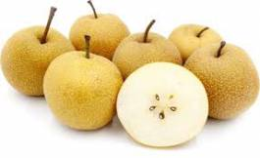](https://www.google.fr/url?sa=i&rct=j&q=&esrc=s&source=images&cd=&cad=rja&uact=8&ved=2ahUKEwizkeWKrrbgAhUt1-AKHRHyDZ8QjRx6BAgBEAU&url=https%3A%2F%2Fwww.lesprodupanier.com%2Ffruits-agriculture-raisonnee%2F731-nashi.html&psig=AOvVaw2Vs5kG2_X0B3nroBfC9rXj&ust=1550066557052746)

**Potage**

**🞟🞟🞟**

**Croque-monsieur**

**Salade**

[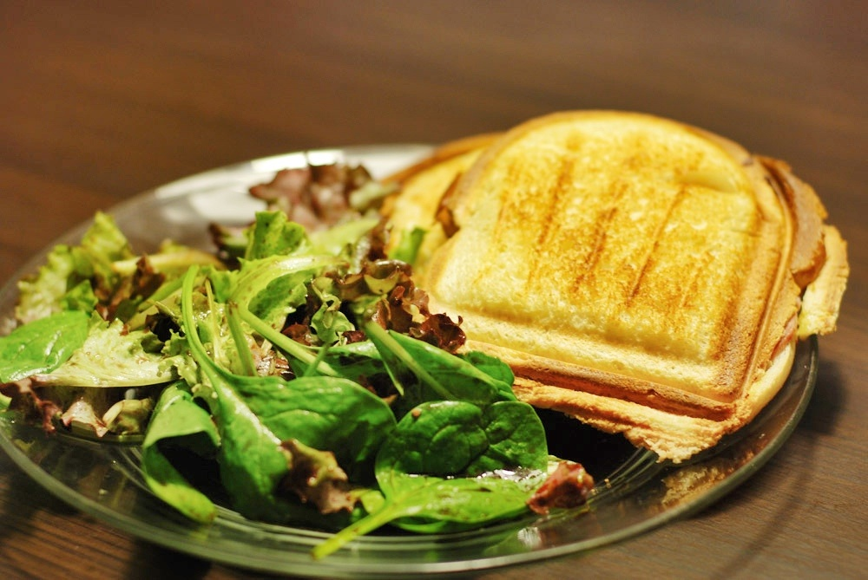](http://www.google.fr/url?sa=i&rct=j&q=&esrc=s&source=images&cd=&cad=rja&uact=8&ved=2ahUKEwjxwv2krrbgAhUAAWMBHSdvCo4QjRx6BAgBEAU&url=http%3A%2F%2Fassiettegourmande.unblog.fr%2F2014%2F10%2F27%2Fcroque-monsieur-et-salade-verte%2F&psig=AOvVaw3N-znY8ETSVy7afDSvqQTp&ust=1550066592835016)

**🞟🞟🞟**

**Fromage**

**🞟🞟🞟**

**Clafouti**

**Quiche**

**🞟🞟🞟**

**Filet de merlu aux crevettes**

**Beignets de légumes**

**🞟🞟🞟**

**Cancoillotte**

[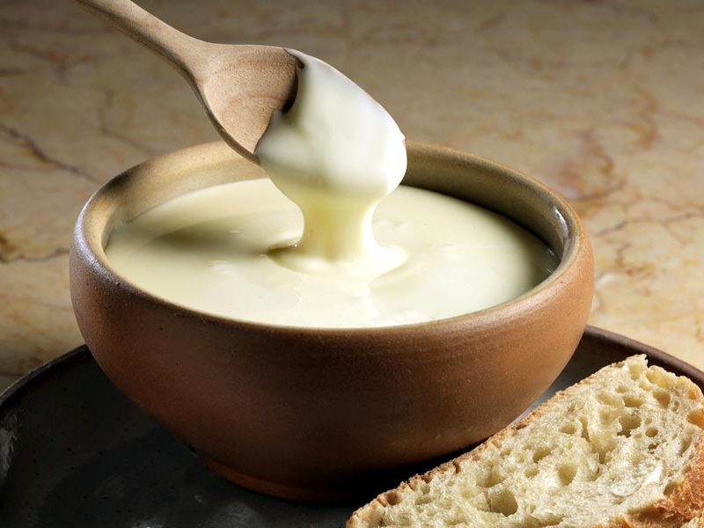](https://www.google.fr/url?sa=i&rct=j&q=&esrc=s&source=images&cd=&cad=rja&uact=8&ved=2ahUKEwiM0LaprbbgAhVHAWMBHQ6WA7cQjRx6BAgBEAU&url=https%3A%2F%2Fwww.cookomix.com%2Frecettes%2Fcancoillotte-thermomix%2F&psig=AOvVaw3fM4Jb4m_nkicB5787tjT-&ust=1550066353553453)

**🞟🞟🞟**

**Dessert de fruit**

**Pomme fraise**

**Crudités**

[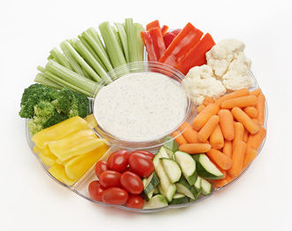](https://www.google.fr/url?sa=i&rct=j&q=&esrc=s&source=images&cd=&cad=rja&uact=8&ved=2ahUKEwjS8KHiqrbgAhUHFRQKHSiPCjcQjRx6BAgBEAU&url=https%3A%2F%2Fwww.caramaps.com%2Fblog%2Ffr%2Fbien-cuisiner-en-camping-car%2F&psig=AOvVaw3R-ZLDcsFsFdyjfOQht2th&ust=1550065649204268)

**🞟🞟🞟**

**Omelette au fromage**

**Pommes de terre rissolées**

**🞟🞟🞟**

**Carré frais**

**🞟🞟🞟**

**Kiwi**

**Salade emmental noix**

**🞟🞟🞟**

**Escalope de dinde aux champignons**

**Gnocchi**

[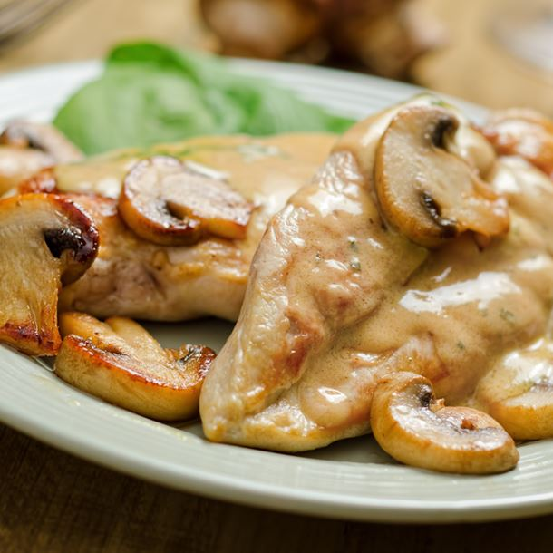](https://www.google.fr/url?sa=i&rct=j&q=&esrc=s&source=images&cd=&cad=rja&uact=8&ved=2ahUKEwj-56XbrrbgAhVo2OAKHTNjCwQQjRx6BAgBEAU&url=https%3A%2F%2Fwww.cuisineaz.com%2Frecettes%2Fescalopes-de-dinde-minceur-aux-champignons-60633.aspx&psig=AOvVaw1J6GwwOe8MY_MSlimWK_9c&ust=1550066733043318)

**🞟🞟🞟**

**Fromage**

**🞟🞟🞟**

**Crumble aux pommes**