***Semaine du 28/01 au 1er/02***

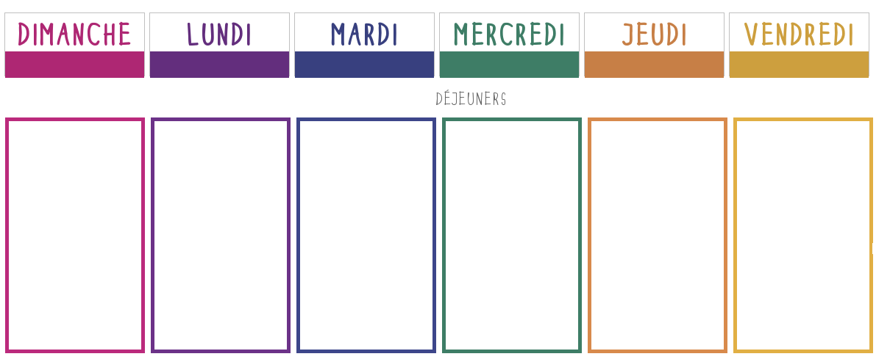

**Quiche**

**Potimarrons**

**Pomme de terre**

**🞟🞟🞟**

**Poisson pané**

**Tian de légumes**

[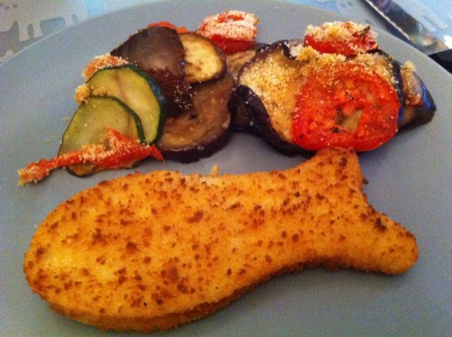](http://www.google.fr/url?sa=i&rct=j&q=&esrc=s&source=images&cd=&cad=rja&uact=8&ved=2ahUKEwiWv56BuuDfAhUMyYUKHebEAVoQjRx6BAgBEAU&url=http%3A%2F%2Fwww.foodreporter.fr%2Fplat%2Fpoisson-pan%25C3%25A9-et-po%25C3%25AAl%25C3%25A9e-de-l%25C3%25A9gumes-%25C3%25A0-la-proven%25C3%25A7ale%2F56282&psig=AOvVaw3y--SLG6l_TBfULYHmqjkX&ust=1547114816822856)

**🞟🞟🞟**

**Fromage**

**🞟🞟🞟**

**Kiwi**

**Salade verte**

[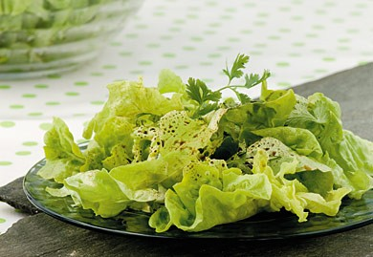](https://www.google.fr/url?sa=i&rct=j&q=&esrc=s&source=images&cd=&cad=rja&uact=8&ved=2ahUKEwiJj5u-uuDfAhUIvxoKHXHjDN8QjRx6BAgBEAU&url=https%3A%2F%2Fwww.lesfruitsetlegumesfrais.com%2Fen-cuisine%2Frecettes%2Fsalade-verte-declinaisons-de-vinaigrettes&psig=AOvVaw2ZexN8ul11TfWV45T4pOdO&ust=1547114906295317)

**🞟🞟🞟**

**Pomme de terre savoyarde**

**🞟🞟🞟**

**Petit suisse**

**🞟🞟🞟**

**Banane**

**Chou blanc lardons emmental**

**🞟🞟🞟**

**Filet de colin aux agrumes**

**Riz**

**🞟🞟🞟**

**Fromage**

**🞟🞟🞟**

**Gâteau aux pommes**

[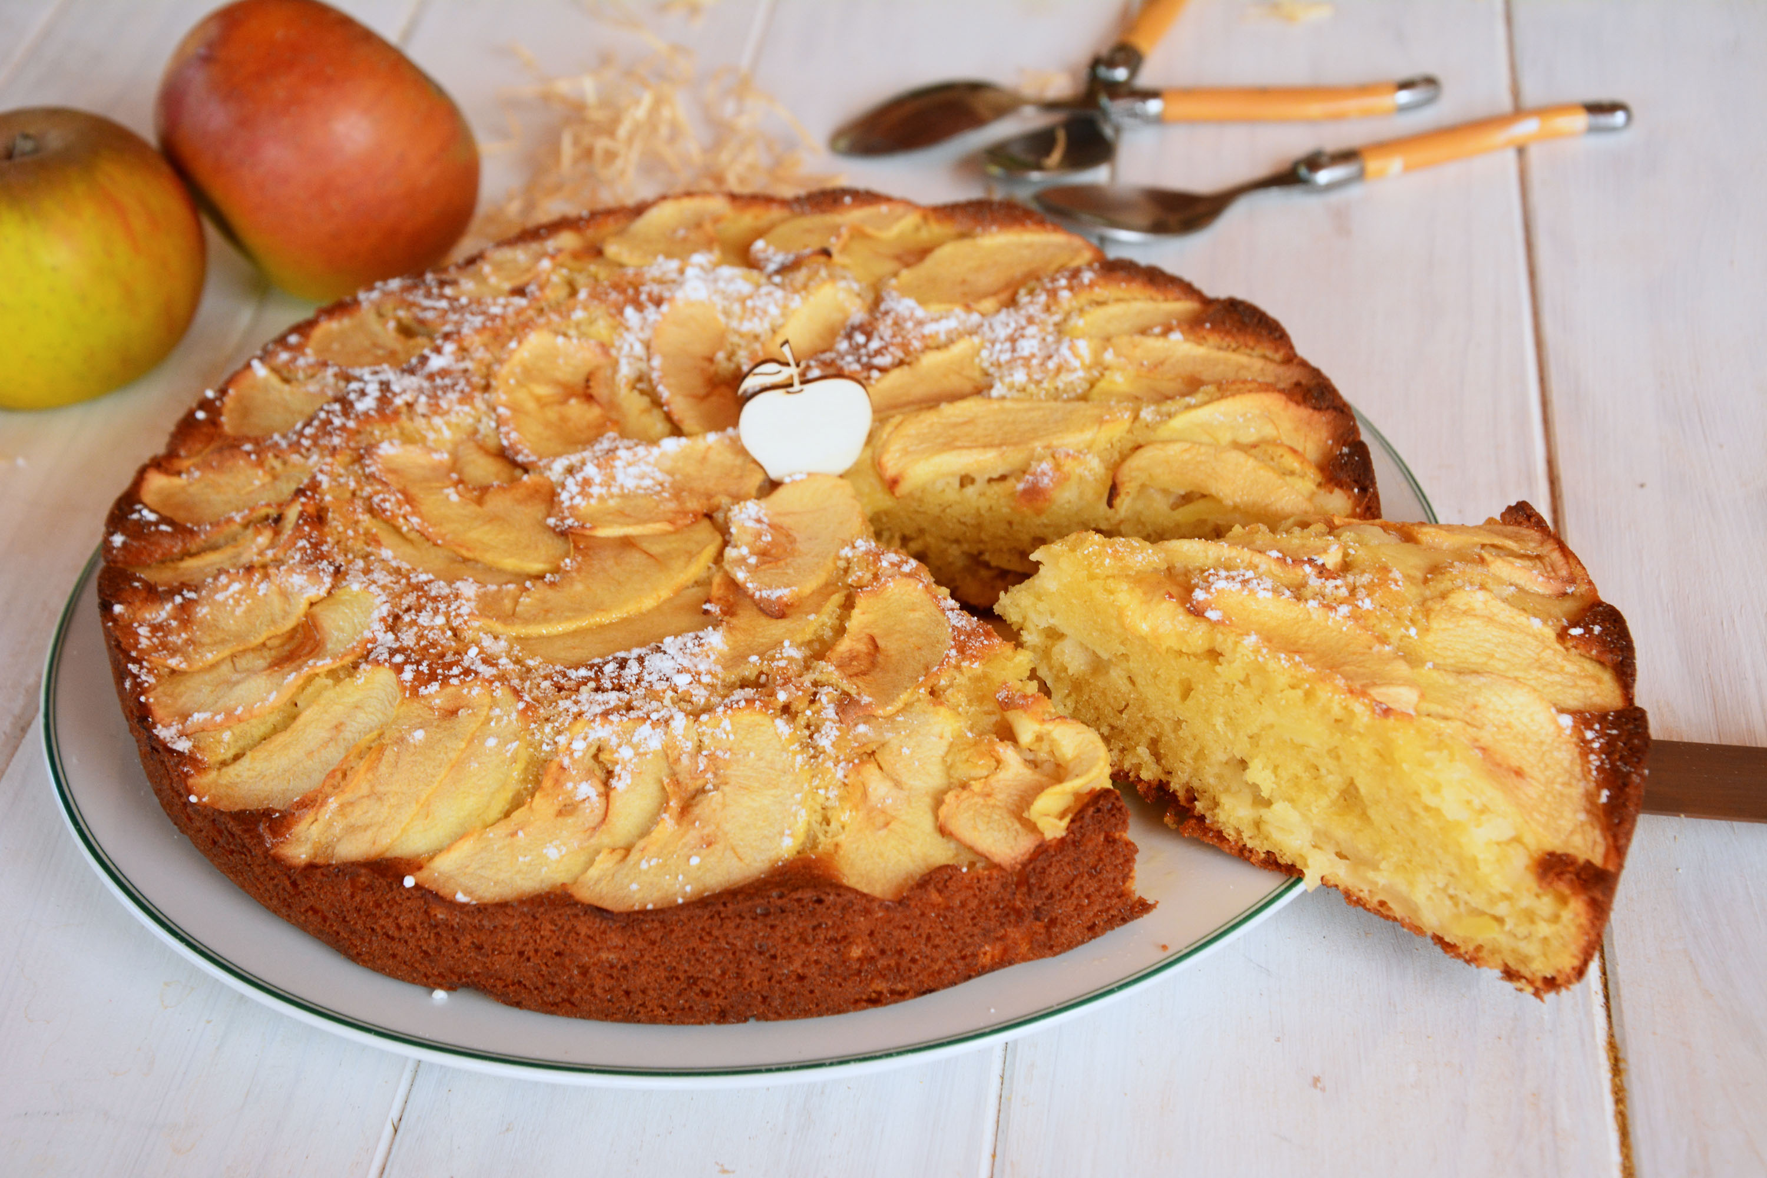](https://www.google.fr/url?sa=i&rct=j&q=&esrc=s&source=images&cd=&cad=rja&uact=8&ved=2ahUKEwj-l9C7ueDfAhVRPBoKHbROD8IQjRx6BAgBEAU&url=https%3A%2F%2Faufilduthym.fr%2Fgateau-aux-pommes-ancienne%2F&psig=AOvVaw05mL_OkI0QRprAIDaex5Ke&ust=1547114661236658)

**Taboulé**

[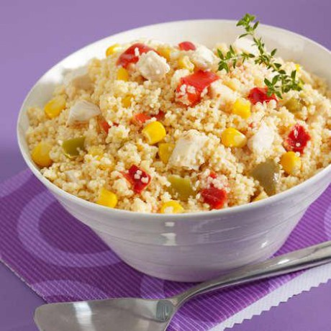](https://traiteur.auchan.fr/taboule-volaille-1-5kg/p-T658191)

**🞟🞟🞟**

**Cordon bleu**

**Purée de carottes**

**🞟🞟🞟**

**Fromage**

**🞟🞟🞟**

**Clémentines**

**Potage**

**🞟🞟🞟**

**Steak haché**

**Gratin de courgettes**

**🞟🞟🞟**

**Fromage**

**🞟🞟🞟**

**Pana cotta mangue**

[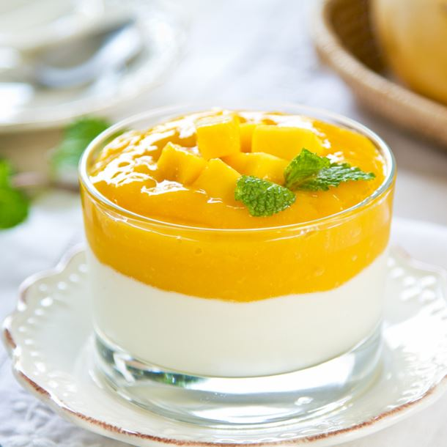](https://www.google.fr/url?sa=i&rct=j&q=&esrc=s&source=images&cd=&cad=rja&uact=8&ved=2ahUKEwi8wpaHuODfAhXQz4UKHQXPBz4QjRx6BAgBEAU&url=https%3A%2F%2Fwww.cuisineaz.com%2Frecettes%2Fpanna-cotta-saveur-coco-et-son-coulis-de-mangue-70331.aspx&psig=AOvVaw1kZkrIJzRakNGLfCCwpeOn&ust=1547114259580268)