[](https://www.google.fr/url?sa=i&rct=j&q=&esrc=s&source=images&cd=&cad=rja&uact=8&ved=2ahUKEwiAh-3vxeDfAhU-gM4BHcUUDQIQjRx6BAgBEAU&url=https%3A%2F%2Fwww.webmarketing-com.com%2F2016%2F02%2F29%2F46115-le-nouvel-an-chinois-nouvelle-vitrine-dun-avenir-high-tech&psig=AOvVaw0XpeWDzaGIAEAxXZ7CDdR8&ust=1547117897267978)[](https://www.google.fr/url?sa=i&rct=j&q=&esrc=s&source=images&cd=&cad=rja&uact=8&ved=2ahUKEwjWmOi8xeDfAhUvzIUKHTZjD9wQjRx6BAgBEAU&url=https%3A%2F%2Fwww.estrepublicain.fr%2Fedition-de-nancy-ville%2F2017%2F01%2F29%2Fnouvel-an-chinois-place-charles-iii&psig=AOvVaw0XpeWDzaGIAEAxXZ7CDdR8&ust=1547117897267978)***Semaine du 04/02 au 08/02***

[](https://www.google.fr/url?sa=i&rct=j&q=&esrc=s&source=images&cd=&cad=rja&uact=8&ved=2ahUKEwiDntedxuDfAhWwxoUKHTI9AskQjRx6BAgBEAU&url=https%3A%2F%2Fwww.amazon.fr%2FBilderdepot24-tatouage-sinogramme-caract%25C3%25A8res-chinois%2Fdp%2FB008MVBHEW&psig=AOvVaw2pmSda6ot4joCphzjQIccv&ust=1547118099562825)

**Salade pomme de terre**

**Haricots verts**

[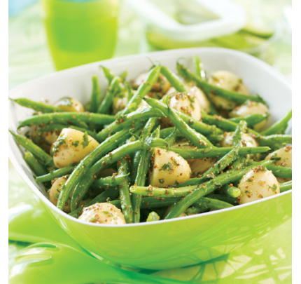](https://www.google.fr/url?sa=i&rct=j&q=&esrc=s&source=images&cd=&cad=rja&uact=8&ved=2ahUKEwi_xonVxODfAhUHdxoKHdl2DhMQjRx6BAgBEAU&url=https%3A%2F%2Fwww.lechoixdupresident.ca%2Ffr_CA%2Frecipes%2Frecipeslisting%2Fperfect_picnic_green_bean_and_potato_salad.html&psig=AOvVaw2gI1cRTijnsw09bTBOEGep&ust=1547117665371620)

**🞟🞟🞟**

**Filet de poisson sauce oseille**

**Gratin de choux fleur**

**🞟🞟🞟**

**Fromage**

**🞟🞟🞟**

**Yaourt**

**Salade de soja**

[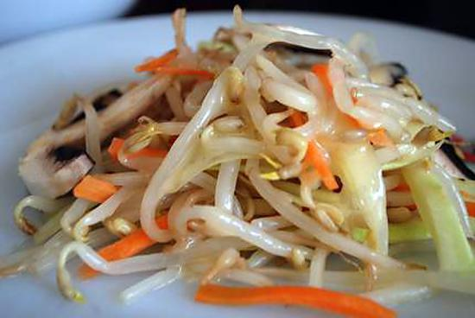](http://www.google.fr/url?sa=i&rct=j&q=&esrc=s&source=images&cd=&cad=rja&uact=8&ved=2ahUKEwiYhI7hu-DfAhUKyRoKHYBqAdQQjRx6BAgBEAU&url=http%3A%2F%2Fwww.lesfoodies.com%2Fprisca%2Frecette%2Fsalade-de-germes-de-soja&psig=AOvVaw3Zq0cbeC7FtP-r3sv5LJ9P&ust=1547115285535527)

**Canard laqué**

**Riz cantonais**

[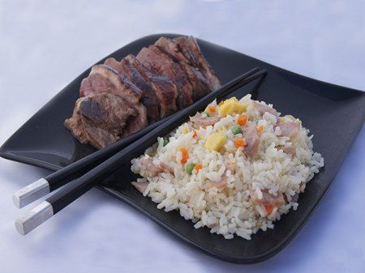](https://www.google.fr/url?sa=i&rct=j&q=&esrc=s&source=images&cd=&cad=rja&uact=8&ved=2ahUKEwjNgu-1u-DfAhVNhRoKHZJ-D1oQjRx6BAgBEAU&url=https%3A%2F%2Fwww.pinterest.fr%2Fpin%2F503558802067015002%2F&psig=AOvVaw01OvSBxtpxEqeOtu7y4m7h&ust=1547115203721156)

**Fromage**

**Boule coco**

[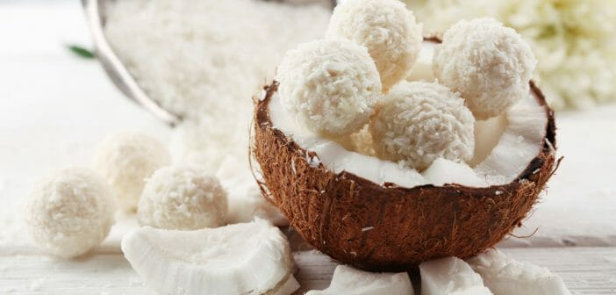](https://www.google.fr/url?sa=i&rct=j&q=&esrc=s&source=images&cd=&cad=rja&uact=8&ved=2ahUKEwjXzqDNu-DfAhUdgM4BHTmQC7QQjRx6BAgBEAU&url=https%3A%2F%2Fanaca3.com%2Fblog%2Fcombien-de-calories-boules-de-coco-chinoises%2F&psig=AOvVaw3gU2r2ZIdVVdn3Y_m88h7X&ust=1547115244099649)

**Concombre à la crème**

**🞟🞟🞟**

**Sauté de bœuf au paprika**

**Purée**

[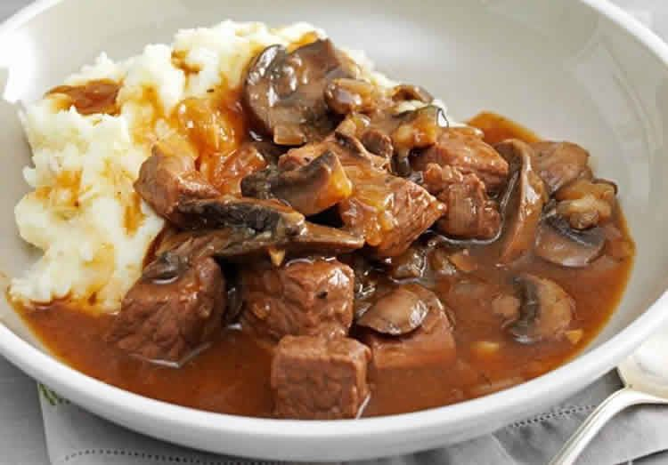](https://www.google.fr/url?sa=i&rct=j&q=&esrc=s&source=images&cd=&cad=rja&uact=8&ved=2ahUKEwiymfKjxODfAhVBhRoKHVvmCZcQjRx6BAgBEAU&url=https%3A%2F%2Fwww.pinterest.com%2Fpin%2F438819557439344973%2F&psig=AOvVaw1gKg4ymWCvYsvNQi8VugoQ&ust=1547117576943285)

**🞟🞟🞟**

**Fromage blanc**

**🞟🞟🞟**

**Fruits**

**Salade aux cœurs d’artichauts**

**🞟🞟🞟**

**Sauté d’agneau**

**Flageolets**

**🞟🞟🞟**

**Fromage**

**🞟🞟🞟**

**Banane chocolat**

[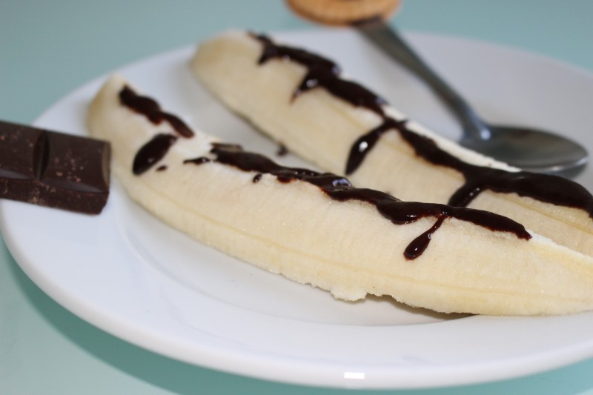](http://www.google.fr/url?sa=i&rct=j&q=&esrc=s&source=images&cd=&cad=rja&uact=8&ved=2ahUKEwju2vajxeDfAhVoxYUKHT62CnkQjRx6BAgBEAU&url=http%3A%2F%2Fwww.dineandmove.fr%2Fbanane-au-chocolat.html&psig=AOvVaw28siCsTf8Li_caOmLAmo2X&ust=1547117824713576)

**Tomate mimosa**

[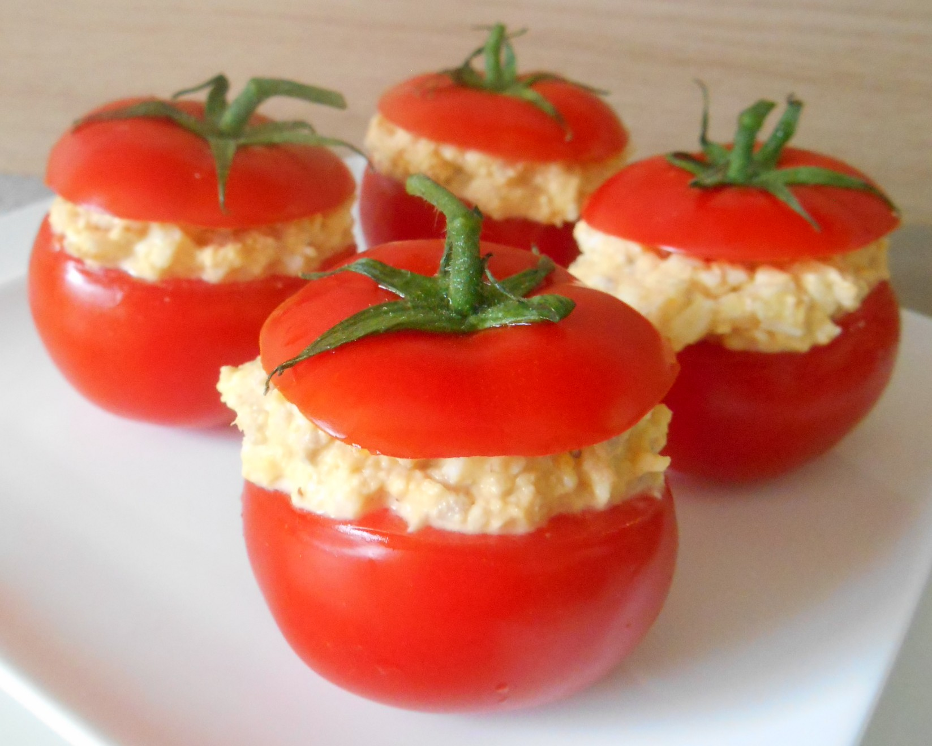](http://www.google.fr/url?sa=i&rct=j&q=&esrc=s&source=images&cd=&cad=rja&uact=8&ved=2ahUKEwic1aiSu-DfAhXhzIUKHW2fChkQjRx6BAgBEAU&url=http%3A%2F%2Fauxmilledelices.com%2Ftomates-farcies-au-thon-oeuf-dur%2F&psig=AOvVaw1TqUzjy81l6g3ZlikpeAWg&ust=1547115122498327)

**🞟🞟🞟**

**Poulet rôti**

**Brocolis**

**Pomme vapeur**

**🞟🞟🞟**

**Fromage**

**🞟🞟🞟**

**Fruit**