[](https://www.google.fr/url?sa=i&rct=j&q=&esrc=s&source=images&cd=&cad=rja&uact=8&ved=2ahUKEwjnooiRtIjeAhUI_qQKHSimAB0QjRx6BAgBEAU&url=https://fr.fotolia.com/tag/%22bonne%20ann%C3%A9e%202019%22&psig=AOvVaw1uU4jOVdCgmU1uvEJE281c&ust=1539691517193891)

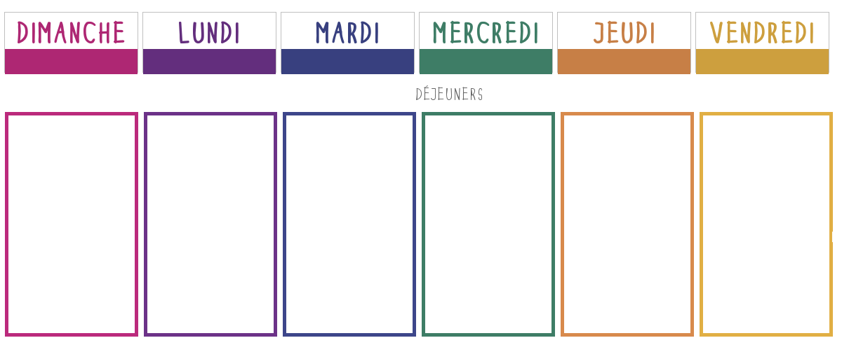***Semaine du 07/01 au 11/01***

**Salade verte aux accras de morue**

**🞟🞟🞟**

**Filet de lieu meunière**

**Gaufres épinards**

**🞟🞟🞟**

**Yaourt nature**

**🞟🞟🞟**

**Litchis**

[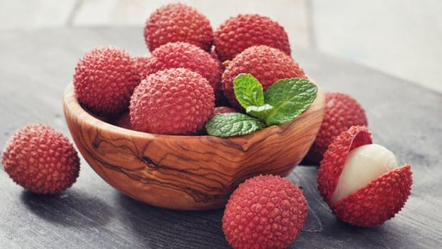](https://www.google.fr/url?sa=i&rct=j&q=&esrc=s&source=images&cd=&cad=rja&uact=8&ved=2ahUKEwittIqFv_feAhVPrxoKHaI1B88QjRx6BAgBEAU&url=https%3A%2F%2Ffood.ndtv.com%2Ffood-drinks%2F9-amazing-lychee-benefits-from-better-digestion-to-weight-loss-1707085&psig=AOvVaw0SyIUbfVKogVdTesQhnNQb&ust=1543508396129798)

**Champignons à la grecque**

**🞟🞟🞟**

**Escalope de dinde à la crème**

**Pâtes**

[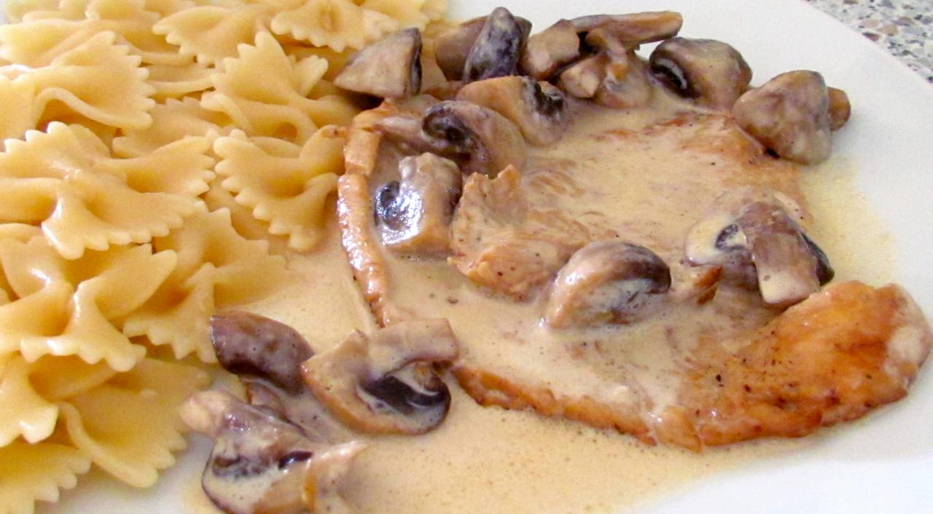](http://www.google.fr/url?sa=i&rct=j&q=&esrc=s&source=images&cd=&cad=rja&uact=8&ved=2ahUKEwj7l9rjvvfeAhWry4UKHWVECJ8QjRx6BAgBEAU&url=http%3A%2F%2Fl-hote-sophie.e-monsite.com%2Fpages%2Fplats%2Fescalope-de-dinde-aux-champignons-et-a-la-creme.html&psig=AOvVaw03IiJkoWtnsu12u_7VJR0h&ust=1543508317810512)

**🞟🞟🞟**

**Fromage**

**🞟🞟🞟**

**Compote**

**Tomates mozzarella**

**🞟🞟🞟**

**Boulettes de bœuf**

**Sauce tomate**

**Cocos blancs**

**🞟🞟🞟**

**Fromage**

**🞟🞟🞟**

**Crêpes**

**Chocolat/Chantilly**

[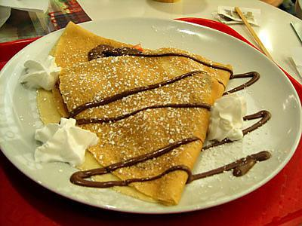](http://www.google.fr/url?sa=i&rct=j&q=&esrc=s&source=images&cd=&cad=rja&uact=8&ved=2ahUKEwiqsaqBvffeAhUtz4UKHVs2AFYQjRx6BAgBEAU&url=http%3A%2F%2Fwww.lesfoodies.com%2Fma671%2Frecette%2Fcrepe-sucree-au-chocolat-et-chantille&psig=AOvVaw3X8YmTnfeHiwsQ4dG5mCr1&ust=1543507688073689)

**Surimi**

[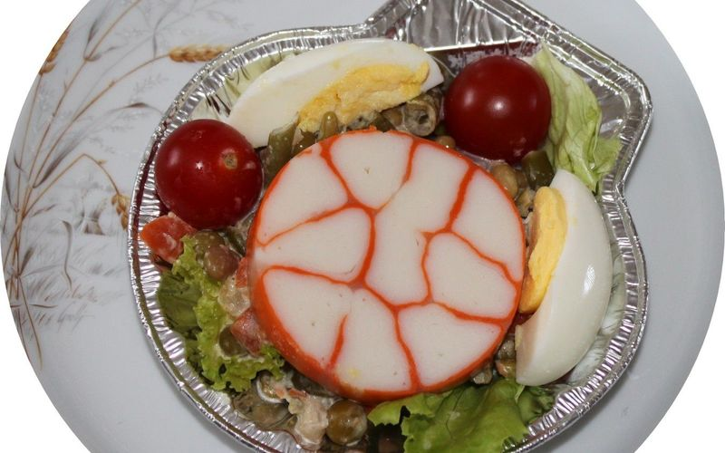](https://www.google.fr/url?sa=i&rct=j&q=&esrc=s&source=images&cd=&cad=rja&uact=8&ved=2ahUKEwigr4Hw2KnfAhVE-YUKHbePD5kQjRx6BAgBEAU&url=https%3A%2F%2Fwww.cuisinorama.com%2Frecette%2F31532-medaillon-de-surimi&psig=AOvVaw3y-4i4ZJijR-K-aFRN3ijJ&ust=1545233315972670)

**🞟🞟🞟**

**Bœuf**

**Carottes**

**🞟🞟🞟**

**Fromage**

**🞟🞟🞟**

**Crêpes**

**Chocolat/Chantilly**

**Friands au fromage**

**🞟🞟🞟**

**Choucroute**

**🞟🞟🞟**

**Galette**

[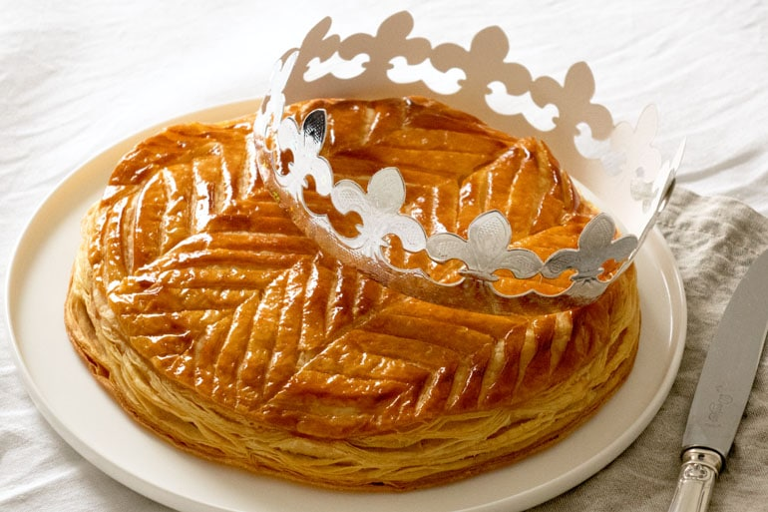](https://www.google.fr/url?sa=i&rct=j&q=&esrc=s&source=images&cd=&cad=rja&uact=8&ved=2ahUKEwiT7YKAu_feAhVEyYUKHWT0AYMQjRx6BAgBEAU&url=https://empreintesucree.fr/galette-des-rois-frangipane/&psig=AOvVaw2fz--Mgk4KJslILN80qHB5&ust=1543507317034094)