***Semaine du 19/11 au 23/11***

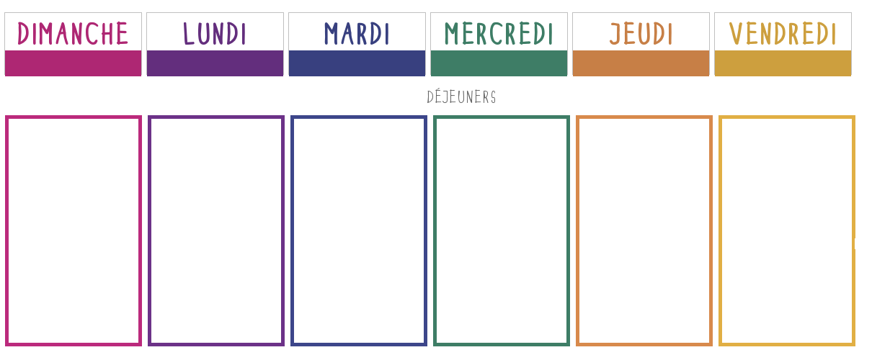

**Quiche thon, tomate**

[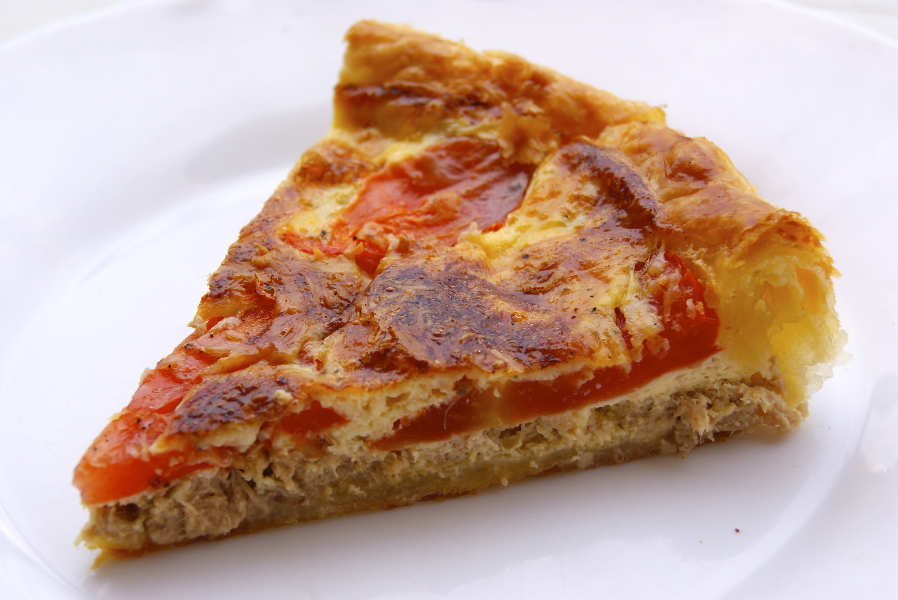](http://www.google.fr/url?sa=i&rct=j&q=&esrc=s&source=images&cd=&cad=rja&uact=8&ved=2ahUKEwihgvGzvcTeAhUKYxoKHXg8BYgQjRx6BAgBEAU&url=http%3A%2F%2Fwww.ptitecuisinedepauline.com%2Farticle-quiche-au-thon-et-a-la-tomate-110131518.html&psig=AOvVaw04CPX3IxY3TLr0yy8TK9zQ&ust=1541755609317799)

**🞟🞟🞟**

**Paupiette de veau**

**Haricots verts**

**🞟🞟🞟**

**Fromage**

**🞟🞟🞟**

**Fruit**

**Potage de légumes**

**🞟🞟🞟**

**Poisson**

**Gratin de pâtes**

**🞟🞟🞟**

**Fromage**

**🞟🞟🞟**

**Viennois**

[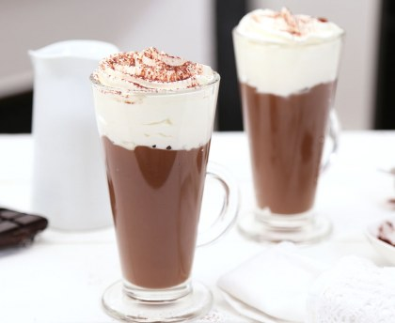](https://www.google.fr/url?sa=i&rct=j&q=&esrc=s&source=images&cd=&cad=rja&uact=8&ved=2ahUKEwinuu6fvcTeAhVKQRoKHfo5D6YQjRx6BAgBEAU&url=https%3A%2F%2Fwww.marmiton.org%2Frecettes%2Frecette_chocolat-viennois_22322.aspx&psig=AOvVaw2VwtHmP02Jj1qM_qNSnWNk&ust=1541755571634719)

**Charcuterie**

**🞟🞟🞟**

**Omelette fromage**

**Champignons entiers**

[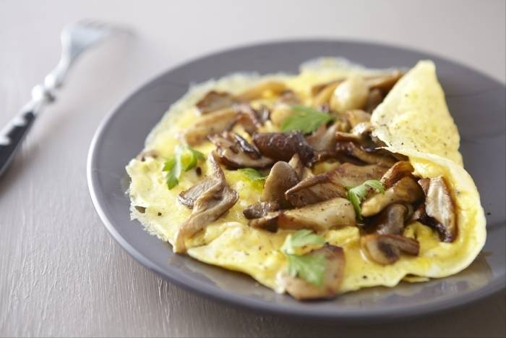](https://www.google.fr/url?sa=i&rct=j&q=&esrc=s&source=images&cd=&cad=rja&uact=8&ved=2ahUKEwjLirmNvcTeAhXpx4UKHdd6AdcQjRx6BAgBEAU&url=https%3A%2F%2Fwww.atelierdeschefs.fr%2Ffr%2Frecette%2F15627-omelette-aux-champignons.php&psig=AOvVaw0omFhR0H4aLGchm4kHn5fk&ust=1541755518067163)

**🞟🞟🞟**

**Petit-suisse**

**🞟🞟🞟**

**Gâteau**

**Toasts de chèvre**

[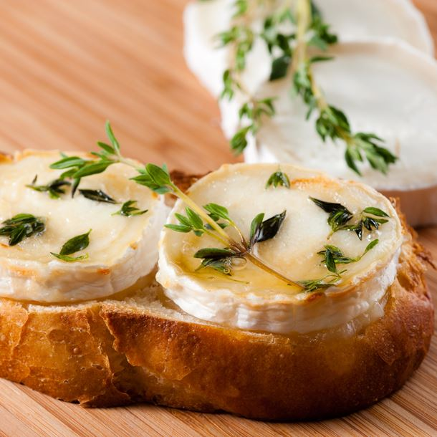](https://www.google.fr/url?sa=i&rct=j&q=&esrc=s&source=images&cd=&cad=rja&uact=8&ved=2ahUKEwjzt560u8TeAhUG0xoKHef8CRkQjRx6BAgBEAU&url=https://www.cuisineaz.com/recettes/aperitif-au-chevre-sur-toast-44685.aspx&psig=AOvVaw3hDw808xSxzmvVuA_wq8KA&ust=1541755073278058)

**🞟🞟🞟**

**Grillade de porc**

**Courgettes**

**🞟🞟🞟**

**Fromage**

**🞟🞟🞟**

**Fruit**

**Betteraves**

**🞟🞟🞟**

**Poulet**

**Frites**

[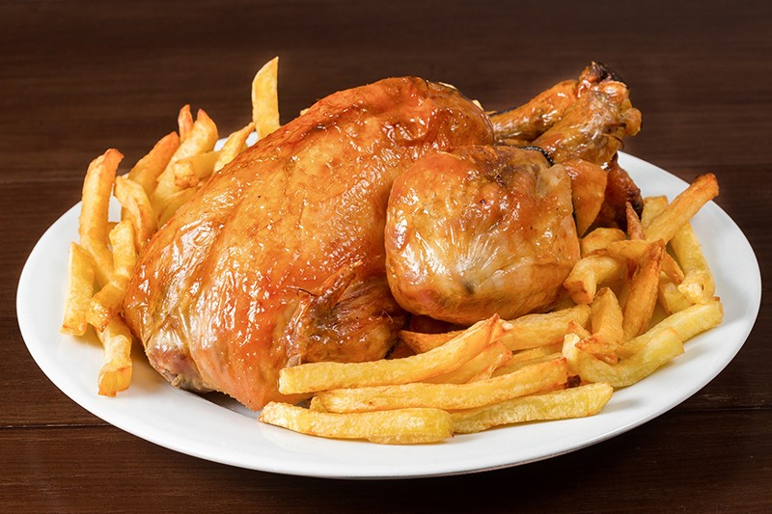](https://www.google.fr/url?sa=i&rct=j&q=&esrc=s&source=images&cd=&cad=rja&uact=8&ved=2ahUKEwj8lZTEu8TeAhUkxoUKHWXuDbwQjRx6BAgBEAU&url=https%3A%2F%2Flacasadelapaella.com%2Fcommande%2Fpoulets-rotis%2F214-poulet-entier-roti-frites-3-portions.html&psig=AOvVaw3EdoupfSdqF7Jn04NC_pXb&ust=1541755115215783)

**🞟🞟🞟**

**Fromage**

**🞟🞟🞟**

**Yaourts**