***Semaine du 14 au 18/09***

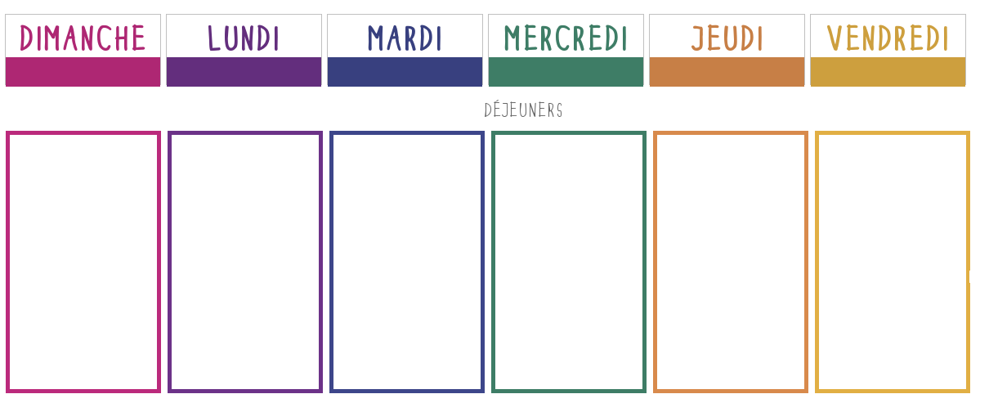

**Pâté en croute**

[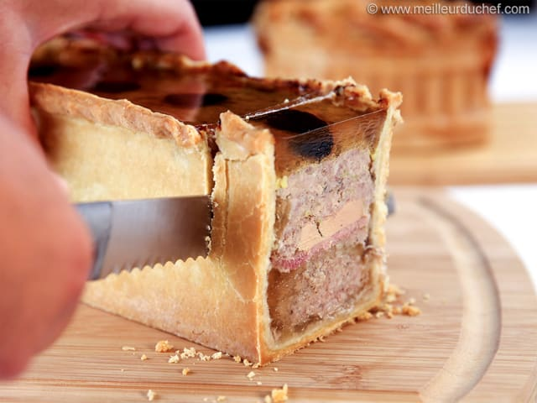](https://www.google.fr/url?sa=i&url=https%3A%2F%2Fwww.meilleurduchef.com%2Ffr%2Frecette%2Fpate-en-croute.html&psig=AOvVaw0-3z2x6UCxZMtxPBJDOlKA&ust=1599295151440000&source=images&cd=vfe&ved=0CAIQjRxqFwoTCIDTq-2Mz-sCFQAAAAAdAAAAABAQ)

**🞟🞟🞟**

**Escalope de dinde**

**Poêlée de légumes**

**🞟🞟🞟**

**Fromage**

**🞟🞟🞟**

**Entremets**

**Concombres**

[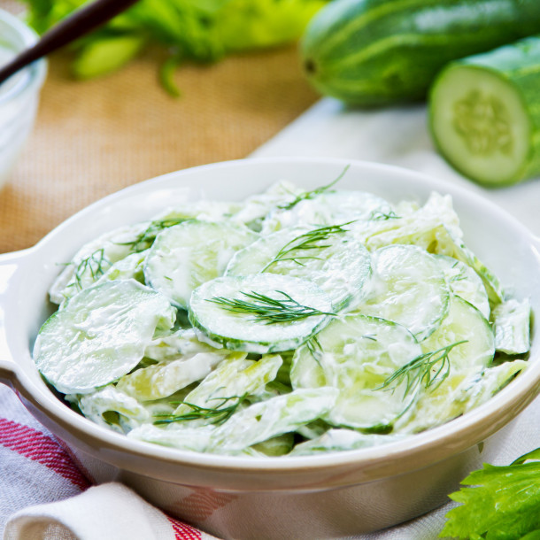](https://www.google.fr/url?sa=i&url=https%3A%2F%2Fwww.cuisineaz.com%2Frecettes%2Fsalade-de-concombre-au-yaourt-29226.aspx&psig=AOvVaw1CgYwvkpZkZ8IMNzL3VUto&ust=1599295109259000&source=images&cd=vfe&ved=0CAIQjRxqFwoTCNDbltmMz-sCFQAAAAAdAAAAABAE)

**🞟🞟🞟**

**Brandade de poisson**

**🞟🞟🞟**

**Fromage**

**🞟🞟🞟**

**Dessert**

**Quiche aux tomates tricolores**

**🞟🞟🞟**

**Œufs à la florentine**

[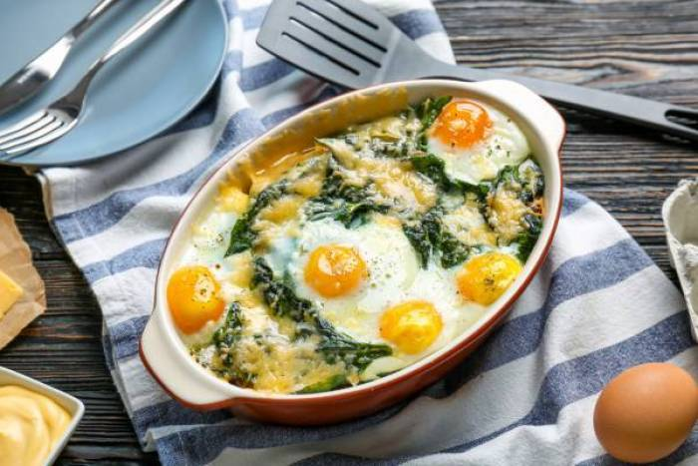](https://www.google.fr/url?sa=i&url=https%3A%2F%2Fwww.atelierdeschefs.fr%2Ffr%2Frecette%2F29517-oeuf-a-la-florentine.php&psig=AOvVaw2HZJmXfoTqZYKvZtnlCODj&ust=1599295057294000&source=images&cd=vfe&ved=0CAIQjRxqFwoTCKCS1cCMz-sCFQAAAAAdAAAAABAK)

**🞟🞟🞟**

**Yaourt**

**🞟🞟🞟**

**Pomme**

**Salade parisienne**

[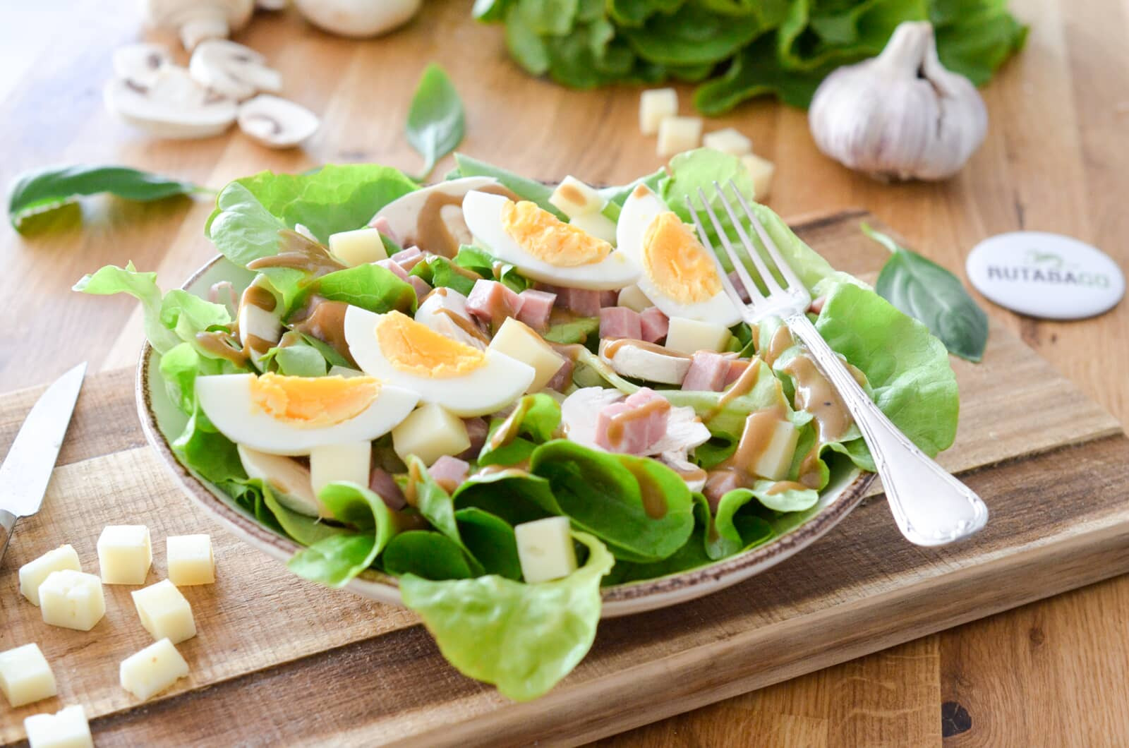](https://www.google.fr/url?sa=i&url=https%3A%2F%2Frutabago.com%2Fblog%2Fviande%2Fsalade-parisienne&psig=AOvVaw1oHUrzg_3wTMCpeynnntLC&ust=1599295741296000&source=images&cd=vfe&ved=0CAIQjRxqFwoTCMi7yIePz-sCFQAAAAAdAAAAABAK)

**🞟🞟🞟**

**Poisson, crustacés**

**Riz**

**🞟🞟🞟**

**Fromage**

**🞟🞟🞟**

**Glace**

**Chou rouge aux pommes**

**🞟🞟🞟**

**Palette ou Saucisses**

**Lentilles**

**🞟🞟🞟**

**Petits filous**

**🞟🞟🞟**

**Melon**

[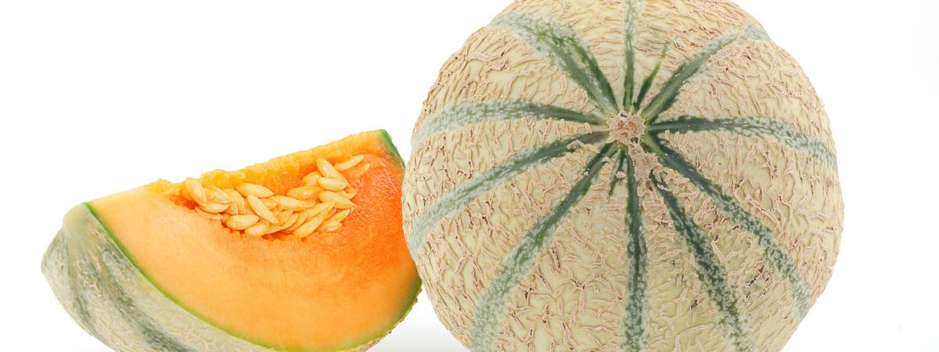](https://www.google.fr/url?sa=i&url=https%3A%2F%2Fwww.francetvinfo.fr%2Freplay-radio%2Fquestion-de-choix%2Fcomment-bien-choisir-un-melon_1784613.html&psig=AOvVaw0TRK15bTAGTMhPdFzhhrEr&ust=1599295468861000&source=images&cd=vfe&ved=0CAIQjRxqFwoTCKDnq4eOz-sCFQAAAAAdAAAAABAD)